**Dashboard Design**

|  |  |
| --- | --- |
| Date | 04 Oct 2025 |
| Team ID | PNT2022TMIDxxxxxx |
| Project Name | **Power BI Inflation Analysis: Journeying Through Global Economic Terrain** |
| Maximum Marks | 5 Marks |

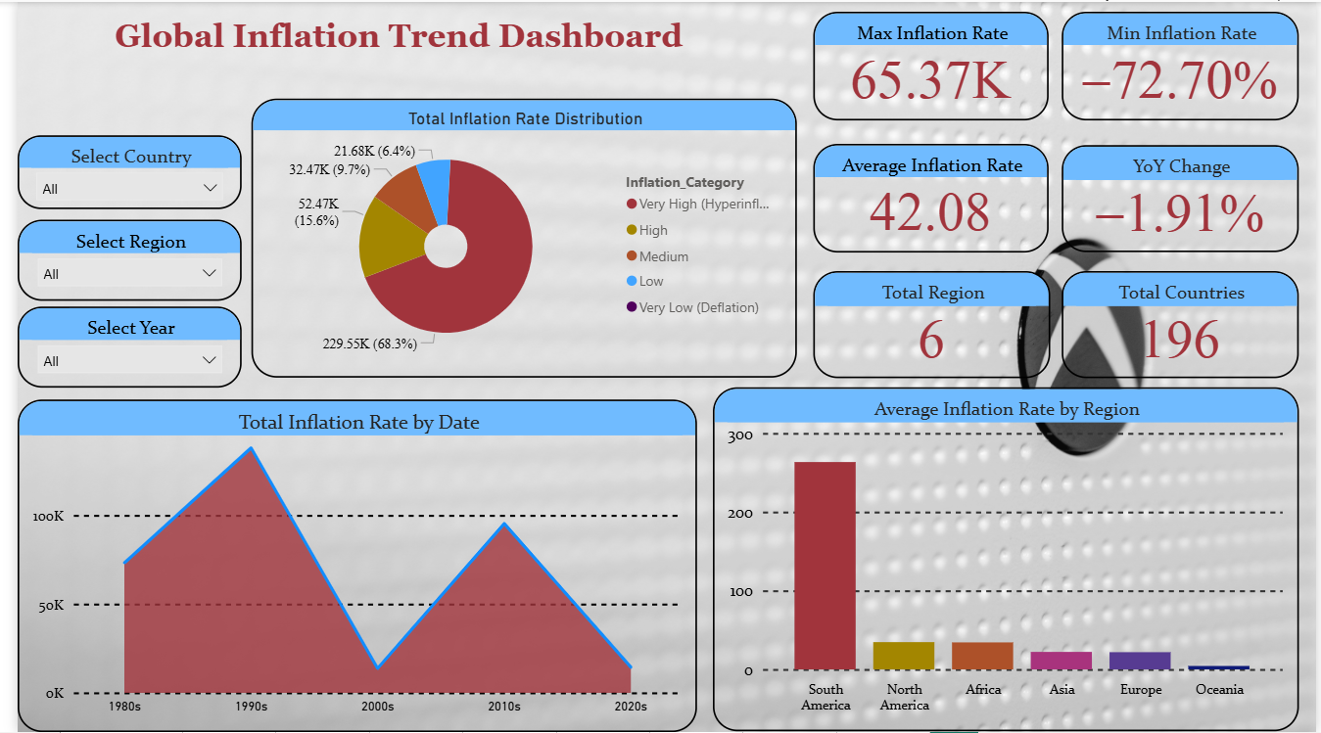

Here are five potential outcomes from the inflation dashboard:

1. **Global Inflation Trends:** Inflation peaked during the early 1990s and 2008 financial crisis, while the 2010s showed relatively stable and low inflation across most regions.
2. **Regional Comparison:** Sub-Saharan Africa and Latin America recorded higher average inflation rates, whereas Europe and North America consistently maintained low inflation.
3. **Top Volatile Countries:** Countries like Venezuela, Zimbabwe, and Argentina exhibited extreme inflation volatility, with fluctuations above 50% in certain years.
4. **Median Inflation Insights:** Median inflation per country indicates that over 60% of countries have historically maintained inflation below 10%, reflecting relative stability compared to hyperinflationary cases.
5. **Decade-wise Patterns:** The 1980s and 1990s were marked by high inflation crises in several developing nations, while the 2020s show inflation spikes linked to the COVID-19 pandemic and global supply chain disruptions.
6. **Missing Data Observations:** Some countries (e.g., Eritrea, Syria, Estonia pre-1991) show missing years, highlighting data quality issues that require imputation or special treatment in analysis.
7. **Regional Recovery:** Asia-Pacific countries recovered more quickly from high-inflation periods compared to African nations, where sustained high inflation remained a challenge.